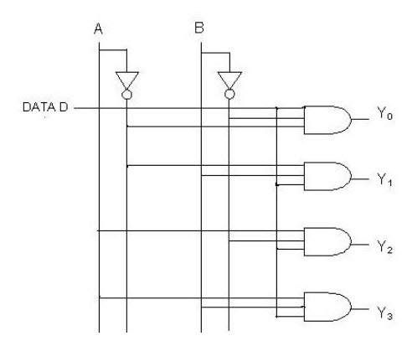**Circuit Diagram & Truth Table:**

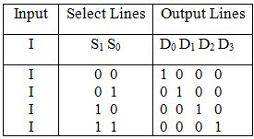

**Code:**

* **Design Module**

module demux(d0,d1,d2,d3,s0,s1,din);

input s0,s1,din;

output d0,d1,d2,d3;

wire x,y;

assign x=~s0;

assign y=~s1;

assign d0=(x&y);

assign d1=(s1&x);

assign d2=(s0&y);

assign d3=(s0&s1);

endmodule

* **TestBench**

module Baig;

reg s0,s1,din;

wire d0,d1,d2,d3;

demux dm(d0,d1,d2,d3,s0,s1,din);

initial

begin

s0=1'b0; s1=1'b0; din=1'b1; #20

s0=1'b1; s1=1'b0; din=1'b1; #20

s0=1'b0; s1=1'b1; din=1'b1; #20

s0=1'b1; s1=1'b1; din=1'b1; #20

$finish;

end

endmodule

**Output:**

